**Security Testing with Raspberry Pi**

Book by Daniel W. Dieterle

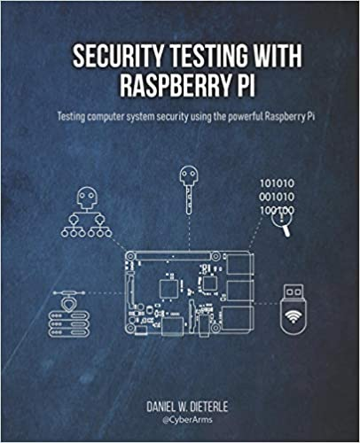

<https://www.amazon.com/Security-Testing-Raspberry-Daniel-Dieterle/dp/1072017679>

Network and System configuration from page 8:

